In this Prior Authorization (PA) Copilot, we have multiple AI agents collaborating on sensitive healthcare workflows (reading medical charts, verifying insurance policies, writing justification letters, and submitting claims).

To make this system enterprise-ready and safe for real hospital environments, we use the two official DeepAgentLabs libraries: AgenticLens and Agentic Chaos.

Here is what each one does and exactly how they work inside this project.

1. High-Level Intuition: The Hospital Analogy

Tool | The Analogy | Real Problem it Solves
AgenticLens | The Hospital CCTV & Telemetry Monitor | Multi-agent systems are black boxes. If a prior auth takes 10 seconds or fails, which agent was slow? Did it hallucinate? AgenticLens gives 100% observability.
Agentic Chaos | The Fire Drill & Stress Test | In real life, insurance payer APIs go down, return timeouts, or reply with broken gibberish. Agentic Chaos deliberately breaks things to prove our copilot won't crash or lose patient requests.

2. How AgenticLens is Used in This Codebase

Whenever a case is processed, it moves through 5 distinct agents. AgenticLens wraps every single agent execution step as a telemetry span.

In agents/base.py:
import agenticlens
from agenticlens import profile, step
with profile(f"PA-Copilot | Case {case_id}"):
with step(
name=step_name,
type=step_type, # 'llm_call', 'retriever', 'planner', 'tool_call'
provider="google",
model="gemini-3.8-flash",
agent_name="Justification Agent",
agent_role="Prior Authorization — justification",
case_id=case_id
):
result = fn(...)

What AgenticLens Captures for Each Step:
1. Agent Step Type:
  - intake → llm_call (Chart parsing via Gemini)
  - policy_match → retriever (Evaluating criteria against policy rules)
  - justification → planner (Medical narrative & confidence score computation)
  - submission → tool_call (Transmitting to the insurance gateway)
  - appeal → llm_call (Drafting peer-to-peer appeal letters)
2. Execution Latency: Exactly how many milliseconds each agent took (e.g. 2,328ms for Intake vs 309ms for Submission).
3. Execution Status: Whether the agent succeeded, failed, or was blocked by a safety guardrail.
4. Audit Trail: Stored under traces/<case_id>.jsonl so doctors and hospital administrators can inspect the step-by-step decision log directly from the UI.

3. How Agentic Chaos is Used in This Codebase

Insurance payer gateways are notoriously brittle. If an insurer's server drops a connection, the AI must not crash, hallucinate a fake approval number, or submit unapproved claims.

In mock_services/chaos_proxy.py, we integrate the real DeepAgentLabs agentic-chaos library:
from agentic_chaos import (
NetworkTimeoutFault,
HTTPErrorFault,
MalformedPayloadFault
)

Chaos Scenarios We Inject & How the Copilot Responds:

Scenario Injected | Fault Mechanism | How Copilot Handles It (Guardrail)
payer_timeout | NetworkTimeoutFault(delay_seconds=30) | Catches the timeout, aborts hanging socket, updates state to submission_failed_timeout, and flags for manual review without dropping the patient request.
payer_500 | HTTPErrorFault(status_code=500) | Prevents unhandled crash; captures HTTP 500 error code and schedules retry.
corrupted_response | MalformedPayloadFault(malformed_json=True) | Intercepts non-JSON garbage returned by a malfunctioning gateway; fails safely rather than causing a JSONDecodeError.
vague_denial | Payer returns a denial without citing a policy clause | In agents/appeal.py, the guardrail detects denials under 40 characters with no criteria cited, suppressing auto-submission and routing directly to Peer-to-Peer Medical Director Review.
Human Review Gate | Attempting submission without approval | In agents/submission.py, if human_approved is False, the agent refuses to transmit over the network.

4. How They Work Together in Real-Time

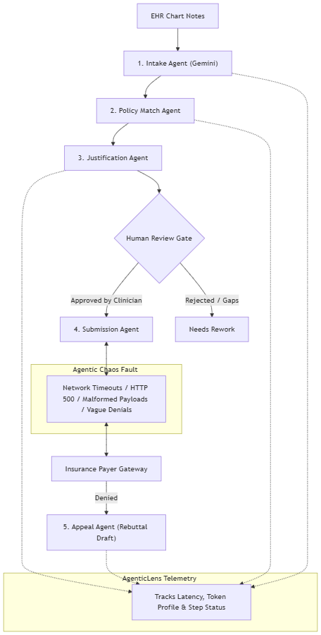

1. Agentic Chaos creates real-world stress and failure modes.
2. AgenticLens records the system's behavior, latency, and step transitions under that stress.
3. The Resilience Scorecard in the UI displays how reliably the Copilot handled each fault scenario.

Viewed pa-copilot-execution-plan.md:79-121

